Simple Chat Server
Project Report

By
Aravind Veluri,
IMTech 1st year,
IIIT Bangalore

General Outline:
Our project is on creation of a simple chat server, to which a client socket is to be connected and then the conversation between the client and server begins. Both the client and server can send and receive messages up to length of 1KB simultaneously. Client and server both can send files of any type to the other in chunks of size 1KB. Empty messages and files that do not exist in the directory of server and client programs cannot be sent from server and client respectively. Client can quit the conversation by sending "quit()" message to the server. The server and client programs can be run from same directory or from different directory in same devices and even from other devices.

Steps:

1.) First, we created a socket in the server file, of address family IPv4, which communicates through TCP internet protocol, and bound it to an IP address(or empty string to accept connections from any device on the same network) of server through a given port and let it listen to and accept connection requests.

2.) Next, from the client file, we created a socket with same address family and protocol, and connected it to the server socket(by entering same IP address and through same port).

3.) Now, after the connection is established, sending and receiving functions are implemented in both the programs.
4.) Two threads, one for sending function and one for receiving function are created and started in order to enable sending and receiving of multiple messages simultaneously from either side. Daemon threads are used to implement the "quit()" part of the program.
5.) Sender and Receiver functions are modified using file handling to enable the transfer of files(in bytes) from either side and creating a new file with the filename "new_<name of sent file>".

6.) Colorama module in installed and imported and is used to format text and background in the terminal.

References:

Colorama module installed from - https://pypi.org/project/colorama/

Working:

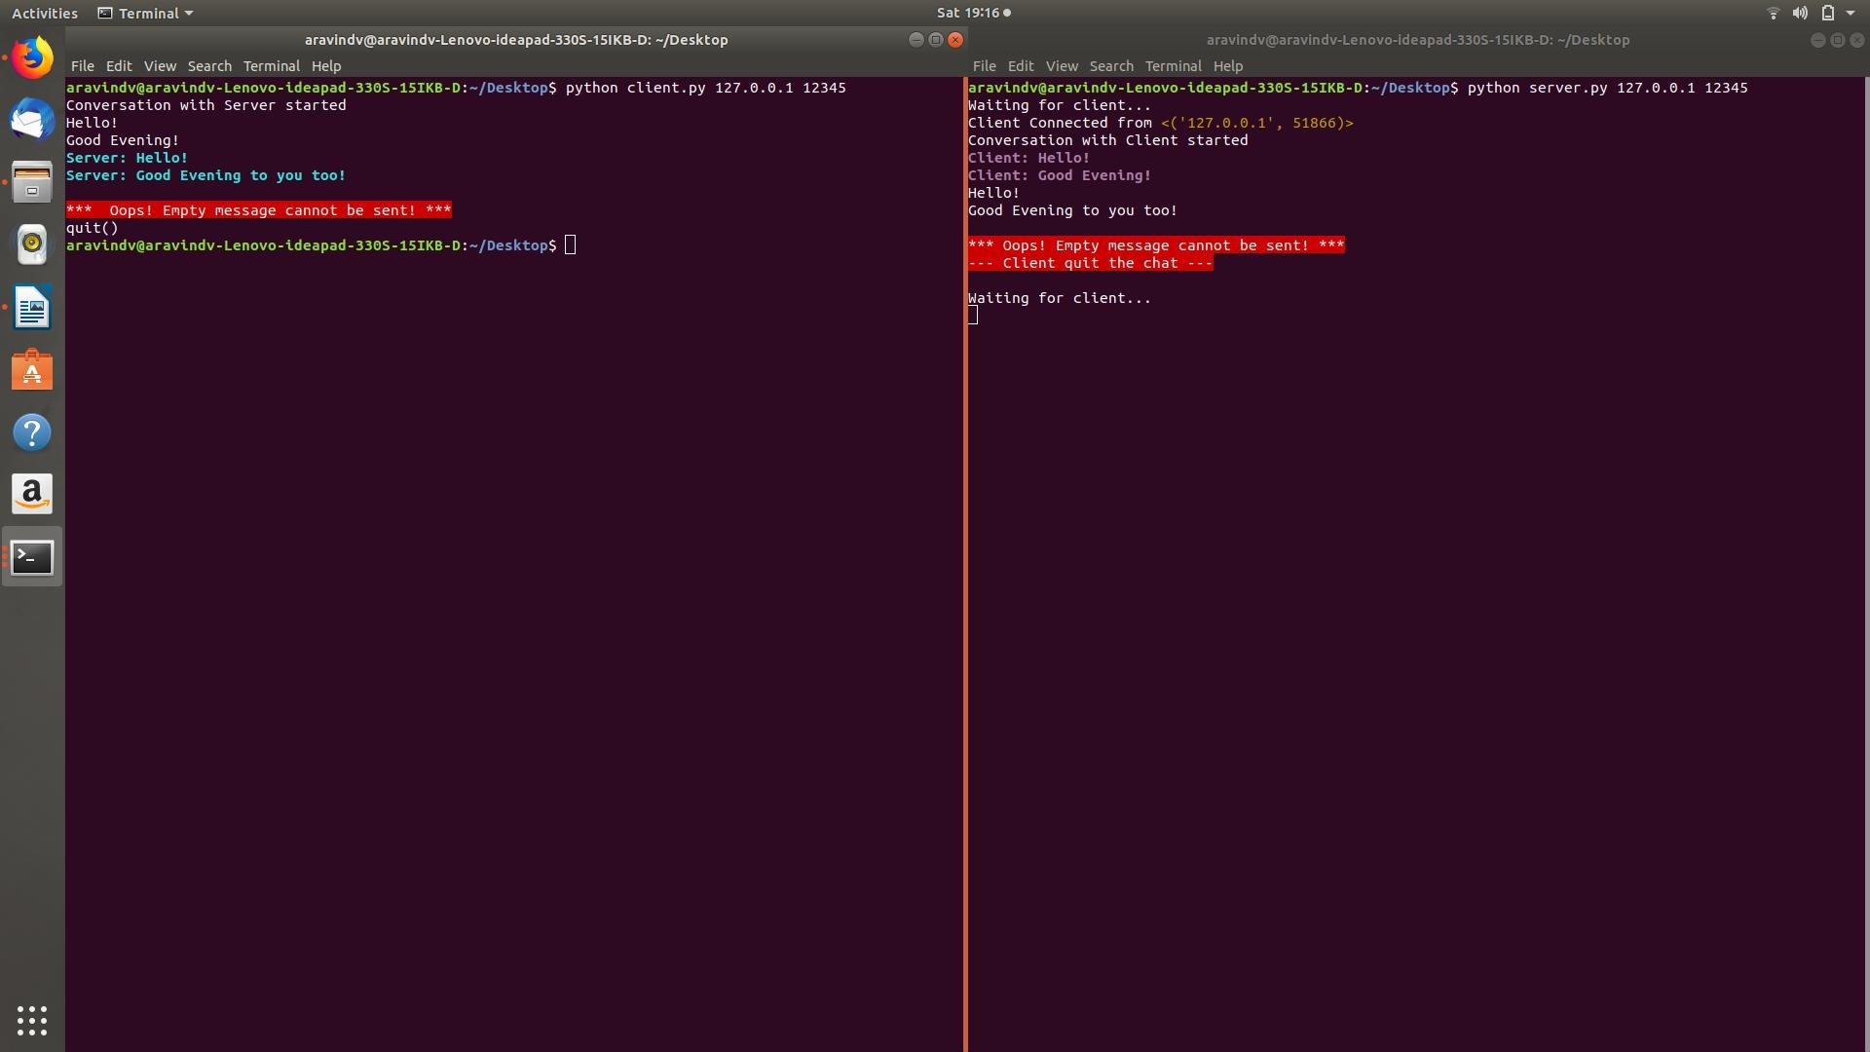

Conclusion:

I created a working server to client communication chat room with a file sending feature. Overall, I was enthusiastic to work on real world application of programming and I want to improve it further.

